# **Template – Adobe Sign Form Sequence with Multiple Signers**

The template named “Template – Adobe Sign” is applicable to CampusNexus Student.

## Purpose and Outcome

This template provides a form sequence and supporting workflow for a form sequence to be completed and signed by the student and a co-signer. The template shows how to use Adobe Sign components for fields such as Signature, Date Signed, and Initials for Signer 1 and Signer 2.

The sequence requires the following:

* A complete **Student record** must exist in the CampusNexus Student database.
* The student must have a **Portal login** to log into this authenticated sequence.

Upon completion of the sequence, the workflow creates a PDF of the form sequence and inserts the PDF into the CampusNexus Student Document Center.

## Prerequisites

The template was built with Forms Builder using the applications listed below. The template is forward compatible with later versions of the listed applications.

|  |  |
| --- | --- |
| **Application** | **Minimum Version** |
| Forms Builder Designer and Renderer | 3.7 |
| Web Client for CampusNexus Student | 21.1 |
| Workflow Composer | 3.0.x |
| Packages installed from Package Manager in Workflow Composer | Activities and Contracts (V1) 21.1.0  Activities and Contracts (V2) 21.1.0  Forms Builder Contracts 3.6.x |
| Workflow Tracking Database | N/A |
| Staff STS 2.1 | 2.1 |

**Prerequisite Settings**

To test the multiple signature feature with Adobe Sign, the test environment needs to meet specific requirements. Adobe Sign will try to call APIs on Renderer when secondary signers complete their signing process via email. This feature is referred to as Webhook.

* If you are testing with an Adobe Sign account in test mode:
  + Renderer must be hosted on port 80 or 443.
  + Port 80 or 443 must be open on the firewall depending on which port Renderer is using for Adobe Sign to communicate. You can request an exception from your IT team for port 80 or 443 for an IP address range.
* If you are testing with a live Adobe Sign account:
  + Renderer must be hosted on port 443 (https).
  + If hosting Renderer on port 443 is not possible, an Adobe Sign representative for your account will have to make an exception.

To confirm that multi-signature forms are completing the workflow process, please confirm that Webhook responses are received and displayed in the log.

## Step 1: Download and Import the Template

1. Download the template file to your environment (local drive or network location).
2. Log into **Forms Builder** and select the **Form Designer tile**.
3. Click the **Export/Import** tile.
4. Select the **Import** tab.
5. Click **Select exported file** and navigate to the downloaded template file.
6. Click **Import**.

* [Export/Import](https://help.campusmanagement.com/FB/3.x/Content/ExportImport.htm)

### The following forms will be imported:

* Welcome
* CMC_Student_Personal_Adobe_Multi
* Default-Frame
* AdobeSignWait
* Default-Confirmation

## Step 2: In Form Designer…

1. From the **Forms** slide out, select the **CMC_Student_Personal_Adobe_Multi** form.
2. Customize the form for your environment. Modify properties on fields/components to make them required, etc., or add/remove fields on form.

This form has multiple **Adobe Sign** components with *Type* property values such as *Signature. Date,* and *Initials* for Signer 1 (student) and Signer 2 (e.g., parent).

* [Fields](https://help.campusmanagement.com/FB/3.x/Content/Fields.htm) and [Components](https://help.campusmanagement.com/FB/3.x/Content/Components.htm)

1. **Save** the form.
2. Adjust the **Welcome** and **Default-Confirmation** forms as appropriate for your institution.
3. On the **AdobeSignWait** form, adjust the text of the HTML component.

Do not modify the Default-Frame form.

## Step 3: In Sequence Designer…

1. Locate the **CMC_DEMO_AdobeSign_Multisign** sequence in the Sequences pane.
2. Click **Save As** to create a copy of the sequence/workflow and customize the copy for your use. This way you can always refer to the original sequence/workflow you downloaded.
3. Optional - Customize the sequence properties for your environment.
4. Optional - Add a custom style (theme) for your campus.

* [Themes](https://help.campusmanagement.com/FB/3.x/Content/Themes.htm)

1. Select your saved sequence in the Sequences pane.
2. In the Properties Pane, select **End State Form** “Default-Confirmation”.
3. **Save** the sequence**.**

## Step 4: In Workflow Composer…

1. Open the workflow for your saved sequence.

* [Opening Workflows for Sequences](https://help.campusmanagement.com/FB/3.x/Content/HostedEnv.htm)

1. Explore the arguments, variables, states, and transitions to get an understanding of the workflow logic. This is a state machine workflow. Each form is a state. The arrows are transitions from one state to another.

* [State Machine Workflows](https://help.campusmanagement.com/FB/3.x/Content/StateMachineWorkflows.htm)

1. Double-click the **Default-Frame** state. This state has several **LogLine** and **LogObject** activities with Level = Error. You can remove these activities or change their Level settings to **Information**.

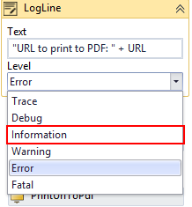

1. If you changed any form names in the sequence, you need to update **PrintUrlToPdf** activity in the Default-Frame state to use form names or forms traversed instead of the Url string.
   * [Updating a Form After Creation of a Sequence](https://help.campusmanagement.com/FB/3.x/Content/AddingEntities.htm) and [PrintUrlToPdf](https://help.campusmanagement.com/FB/3.x/Content/Workflow/PrintUrlToPdf.htm)
2. Below the GetAdobeSignConfig activity in the Default-Frame state, you will find **Assign** activities for the following values:

|  |  |
| --- | --- |
| **Assign To** | **Value** |
| AdobeSignConfig.EmailSubject | "CMC Campus DocuSign Testing" |
| AdobeSignDocument.DocumentId | 1 |
| AdobeSignDocument.Name | AdobeSignDocument.Name |
| AdobeSignDocument.Content | Pdf |
| AdobeSignRecipient.FirstName | AdobeSignRecipient.FirstName |
| AdobeSignRecipient2.FirstName | "Mama" |
| AdobeSignRecipient2.LastName | studentEntity.LastName |
| AdobeSignRecipient2.Email | parentEmail |
| AdobeSignRecipient2.SignerId | "2" |

1. Modify the value for **AdobeSignConfig.EmailSubject** for your use case.
2. Modify the values for **AdobeSignRecipient2.FirstName** and **AdobeSignRecipient2.LastName**, and **AdobeSignRecipient2.Email** for your use case.

Notice that the AdobeSignRecipient2.Email is assigned the **parentEmail** value. This value is passed as an argument from the Model property of the Text Box component in the Additional Signers section of the CMC_Student_Personal_Adobe_Multi form.

You could add Text Boxes to have users enter the first and last name of the second signer and pass the Model values as arguments to the workflow. You would then update the Assign statements for AdobeSignRecipient2.FirstName and AdobeSignRecipient2.LastName using the Model values of the Text Box components.

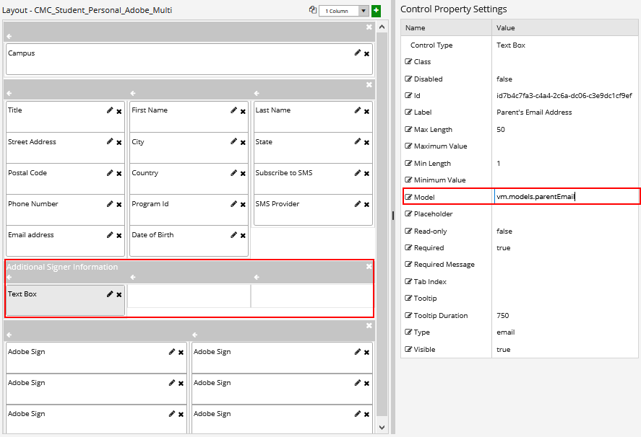

1. Click the **Done transition** at the end of the workflow**.** At this point the workflow takes the signed PDF and updates the document center in the CampusNexus Student database.

This workflow section checks if the document is assigned to the student record.

* If it is, the workflow updates it by inserting and attaching the signed PDF and updating the document status.
* Otherwise, the workflow creates the document, attaches the signed PDF, and updates the document status.

Based on the values configured in your database, modify the **CreateDocument** activity to select appropriate values for Document Type and Document Status.

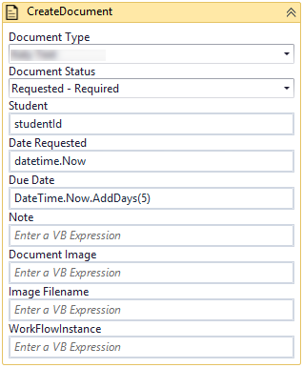

1. Click the **Publish** button in the ribbon of Workflow Composer. Select the check box **Enable This Workflow Version?** and click **Publish.**
   * [Saving and Publishing Workflows](https://help.campusmanagement.com/WF/Content/Workflow/PublishWorkflow.htm)

## Step 5: In Forms Renderer…

Select your sequence and try it out!

* [Sequence List](https://help.campusmanagement.com/FB/3.x/Content/SequenceList.htm)

1. Find your **CMC_DEMO_AdobeSign_Multisign** sequenceand copy the **URL** to the clipboard.
2. Paste the URL into a browser and complete the form sequence.
3. In CampusNexus Student, verify that the staff member’s address information is updated as specified in the form sequence.

## Step 6: Lastly…

Once your updated sequence has been tested successfully, it is recommended that you disable the workflow for the original Template version.

1. In Workflow Composer, in the Server section of the ribbon, click **Open**.
2. Find the workflow named **CMC_DEMO_AdobeSign_Multisign**.
3. Clear the **Enabled** check box and click **Save**.